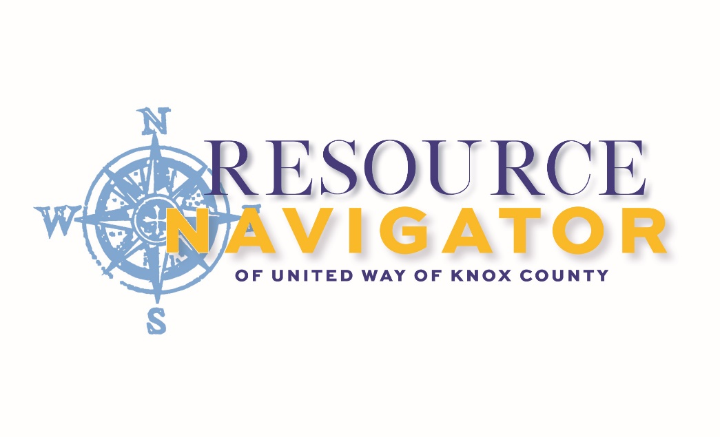
305 East High Street
Mount Vernon, OH 43050

General Information: 740-397-5721
www.uwayknox.org/Resources
Facebook: @navUWayknox

09.12.2023
HOUSING ASSISTANCE
Interchurch Social Services | 740-397-4825
KnoHoCo-Ashland Emergency Shelter | 740-393-3545
Knox Metropolitan Housing | 740-397-8787
The Salvation Army | 740-392-8716
Winter Sanctuary Homeless Shelter | 740-392-9277
FOOD AND NUTRITIONAL SUPPORT
Adventists Caring Through Sharing (ACTS) | 740-397-1065
Apostolic Christian Church | 740-393-1676
Center of Hope | 740-200-0689
Central Christian Church of Mount Vernon | 740-397-1840
The Church on the Rise | 740-397-9022
Covenant Church | 740-392-3152
Get Healthy Knox: Knox Public Health (comprehensive food guides) | 740-392-2200
Interchurch Social Services | 740-397-4825
Job and Family Services | 740-397-7177
The Salvation Army | 740-392-8716
Sanctuary Community Action-Danville | 740-599-7224
Women, Infants, & Children (WIC): Knox Public Health | 740-392-2200
CLOTHING AND HOUSEHOLD ITEMS
Adventists Caring Through Sharing (ACTS) | 740-397-1065
The Church on the Rise | 740-397-9022
Gay Street United Methodist Church | 740-392-6626
Goodwill Knox | 740-393-0081
HopeNow Furniture Bank | 740-358-1277
Interchurch Social Services | 740-397-4825
Knox County ReStore | 740-392-9214
HEALTHCARE AGENCIES AND MEDICAL INSURANCE/SUPPLIES
Job and Family Service | 740-397-7177
KnoHoCo-Ashland Health Services | 740-397-0145
Knox Community Health Center | 740-399-8008
Knox Public Health | 740-392-2200
Knox Starting Point Pregnancy | 740-393-0370
Service Medical Oxygen | 740-393-0202

UTILITY EMERGENCY ASSISTANCE
KnoHoCo-Ashland CAC | 740-397-0378
Job and Family Services | 740-397-7177
Interchurch Social Services | 740-397-4825
The Salvation Army | 740-392-8716
FAMILY SUPPORT
The Freedom Center | 740-397-2660
Job and Family Services | 740-397-7177
Hospice of Knox County | 740-397-5188
Knox Help Me Grow: serving families of children with developmental delays | 740-393-5720
Knox County Head Start | 740-397-9304
NAMI Knox County | 740-397-3088
Parent Support Initiative of Knox County | 740-397-2840
Knox Starting Point Pregnancy | 740-393-0370
TouchPointe Marriage and Family Services | 740-485-5408
The Village Network | 740-397-7568
KNOX COUNTY SERVICES
Children’s Services | 740-392-5437
Child Support Enforcement Agency | 740-397-7177
Job and Family Services | 740-397-7177
Clerk of Courts: Common Pleas | 740-393-6788
Clerk of Courts: Municipal | 740-393-9510
Knox County Probate/Juvenile Court | 740-393-6798
Knox County Sheriff | 740-397-3333
Knox County Task Force for Older Adults | 740-397-2417
Knox County Victim Assistance Program | 740-397-3404
Knox County Veterans Service Office | 740-393-6742
LEGAL ASSISTANCE
Ohio Bar Association www.ohiolegalhelp.org
Southeastern Ohio Legal Services | 740-345-0850

EMERGENCY CONTACT NUMBERS
24 HR Mental Health Crisis Line (National) | 988
Behavioral Healthcare Partners (BHP) Care Now Clinic | 740-324-7800
Child Abuse Reporting (monitored 7:30 AM-4:30 PM) | 740-397-7177
Child Abuse Reporting (after hours) | 740-392-5437
Elder Abuse Reporting | 740-392-5437
Developmental Disabilities Emergency | 740-501-4592
National Human Trafficking Resource | 888-373-7888
New Directions: Domestic Violence and Sexual Violence Support | 740-397-4357
OPIATE SPECIFIC RESOURCES
Overdose Response Team | 211
Knox Public Health-NARCAN | 740-392-2200
Conway’s Eastside Pharmacy-NARCAN | 740-397-1420
Conway’s Danville Pharmacy-NARCAN | 740-481-2300
Foster’s Pharmacy Mount Vernon-NARCAN | 740-392-0911
Foster’s Pharmacy Centerburg-NARCAN | 740-625-7626
The Freedom Center | 740-397-2660
Prescription Drop Boxes: MVPD and Knox County Sheriff Offices
BED BUG RESOURCES
David D. Duncan Pest Control | 419-560-6757
Helmick’s Exterminating | 740-397-6998
Knox Public Health | 740-392-2200
OLDER ADULT SUPPORT
Area Agency on Aging | 419-524-4144
Knox County Task Force for Older Adults | 740-397-2417
Senior Health & Wellness Program: Knox Public Health | 740-392-2200
COUNSELING SERVICES
Alcoholics Anonymous | 740-393-2439
Narcotics Anonymous | 740-397-2660
Narcotics Anonymous (Ohio) | 800-587-4232
ANEW Behavioral Health | 740-326-6110
Behavioral Healthcare Partners (BHP) | 740-397-0442
Family Life Counseling | 740-848-1010
The Freedom Center | 740-397-2660
Lindsay Miller Professional Clinical Counselor | 740-392-5399
COUNSELING SERVICES cont.
The Main Place | 740-392-9491
Mount Vernon Psychological Services | 740-392-5416
New Vision at Knox Community Hospital | 740-212-1887
Riverside Recovery Services | 740-326-9255
Sojourners Counseling | 740-393-6001
The Village Network | 740-397-7568
EMPLOYMENT SUPPORT
Job and Family Services | 740-397-7177
Ohio Means Jobs | 740-392-9675
Opportunity for Ohioans w/Disabilities (Ohio) | 800-354-6271
TouchPointe Marriage and Family Resources | 740-485-5408
TRANSPORTATION
Knox Area Transit (KAT) | 740-392-7433
Knox Mobility Management | 740-485-5002
Non-Emergency Transportation (NET) | 740-393-5306

